LEVEL 1 REFEREES COURSE
Theory Paper
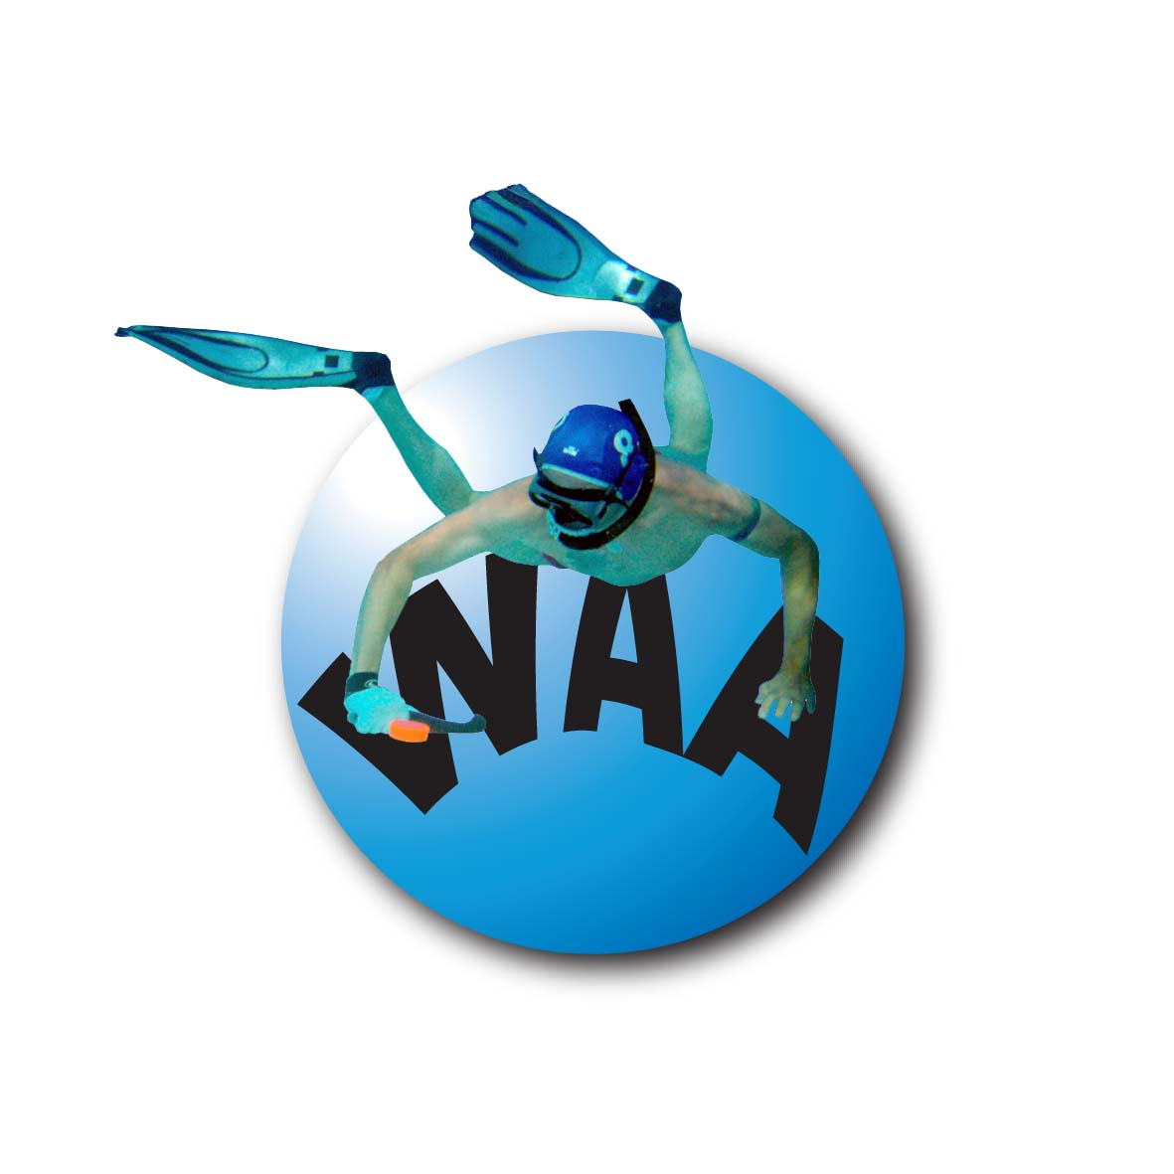

Name: ........………………..

Address: ........………………..

........………………..

Date: ........………………..

Mark: ........………………..

Pass / Fail: ........………………..

Do the exam as open book (i.e. you MAY look at the rules and/or refereeing manual while completing it).
The maximum allowable exam time is 90 minutes. Please attempt all questions. Some questions require a written answer, whilst others are multiple choice. Some multi-choice questions may have more than one correct answer, so mark them as you feel is appropriate.
The total score for the 33 questions is 100 marks
The pass grade is 95%.
QUESTION 1: (2 MARKS)

What are the ideal dimensions of the playing area?
QUESTION 2: (2 MARKS)

Under what conditions does the advantage rule come into play?
QUESTION 3: (3 MARKS)

For any one game, how many interchange players are there, and when may they be used?
QUESTION 4: (2 MARKS)

Under what conditions, and by whom, may timed play be stopped?
QUESTION 5: (3 MARKS)

List the responsibilities of the Timekeeper?
QUESTION 6: (3 MARKS)

What equipment should a Water Referee carry or wear?
QUESTION 7: (3 MARKS)

List three (3) examples of special match conditions that Referees may be required to brief the teams on, prior to a match?

a.
b.
c.
QUESTION 8: (3 MARKS)

List the responsibilities of the Scorer?

a. Prior to the match
b. During the match
c. After the match
QUESTION 9: (15 MARKS)

- List three (3) fouls that would generally be considered as Minor fouls, resulting in an advantage puck?
- List three (3) fouls that would generally be considered as Minor fouls, resulting in a 1 minute time penalty?
- List three (3) fouls that would generally be considered as Major fouls, resulting in a 2 minute time penalty?
- List three (3) fouls that would generally be considered as Major fouls, resulting in a 5 minute time penalty?
- List two (2) fouls that would generally be considered as Serious fouls, resulting in the dismissal of a player for the remainder of the game?
QUESTION 10: (2 MARKS)

By whom, when and how, is play restarted when a free puck, equal puck or penalty shot is awarded?
QUESTION 11: (2 MARKS)

When and where should the gear inspection be conducted?
QUESTION 12: (4 MARKS)

What should a Water Referee look for and check, during a gear inspection?
QUESTION 13: (4 MARKS)

What issues should the Referees discuss with each team prior to a game?
QUESTION 14: (2 MARKS)

Under what circumstances is a penalty shot awarded?
QUESIION 15: (2 MARKS)

When would a Water Referee judge that a penalty shot has concluded?
QUESTION 16: (3 MARKS)

When and how does a Water Referee signal a stop to play?
QUESTION 17: (3 MARKS)

When and how does a Poolside Referee signal a stop to play?
QUESTION 18: (3 MARKS)

If a match result is required, what happens at the end of the second half, if the scores are tied?
QUESTION 19: (2 MARKS)

Under what circumstances is a free puck awarded?
QUESTION 20: (2 MARKS)

Under what circumstances is an equal puck awarded?
QUESTION 21: (2 MARKS)

What is indicated when a Water Referee keeps one arm raised in the air?
QUESTION 22 – circle correct answer (2 MARKS)

After a goal is scored, when should the signal to restart play be given by the Poolside Referee?

- As soon as all members of each team have reached their respective goal lines.
- After a reasonable time has been allowed (roughly 30 sec.) for all players to reach their goal lines.
- When both Water Referees are signalling their readiness for play to commence and a reasonable time has been allowed for players to return to their ends.
- As soon as either Water Referee signals that the puck has been placed on the centre spot, regardless of whether the players have reached their respective goal lines.

QUESTION 23: (2 MARKS)

Correctly voiced protests should be:

- Resolved immediately by the Water Referees
- Recorded by the Scorer for resolution after the match
- Always directed to the Chief Referee for immediate resolution
- Resolved by the Poolside Referee immediately

QUESTION 24: (2 MARKS)

When is play started by the Poolside Referee?

- At the beginning of any time period.
- When a free puck is awarded.
- After a goal is scored.
- When a penalty shot is awarded.
- After a penalty shot is concluded.
- When an equal puck is awarded.
- All of the above.

QUESTION 25: (3 MARKS)

When a free puck is awarded and possession is not taken within 5 seconds of the signal to start play, what action should the Water Referee take?

- Signal a stop to play and award a free puck to the opposing team
- Allow players from either team to take possession
- Signal a stop to play and award an equal puck
- Signal a stop to play and replay the free puck

QUESTION 26: (2 MARKS)

What penalty if any is awarded against a player who commits a major foul?

- A 2 or 5 min time penalty against the player, and a free puck awarded to the opposing team
- Dismissal for the remainder of the match
- A caution if it is his/her first foul and an equal puck awarded
- A caution if it is his/her first foul and a free puck awarded to the opposing team

QUESTI0N 27 (2 MARKS)

At what instant does the Timekeeper commence the timing of a time penalised player?

- As soon as the player has been informed of the penalty.
- As soon as the player's body and equipment is wholly out of the water.
- When the signal to restart play is given, so long as the offending player is in the designated time penalty area.
- As soon as the offending player's body and equipment is wholly in the designated time penalty area.

QUEST1ON 28: (2 MARKS)

By whom and at what time may protests be lodged?
- By any player at any time during the game.
- By the Captain at any time during or after the game.
- By the Captain at any time during the game when play has been stopped by the Water Referee.
- By the Captain only after a goal is scored or at half time.

QUESTION 29: (2 MARKS)

A Water Referee will signal a goal as soon as ………. ?

- The puck has come to rest flat in the trough of the goal.
- He/she sees that the entire puck has wholly entered the goal volume, and makes contact with either the back and/or bottom of the trough.
- The puck is touching some part of the bottom of the trough.
- He/she sees that the entire puck has passed the Anterior Lip (the line that separates the back edge of the ramp from the front edge of the trough.)

QUESTION 31: (10 MARKS)

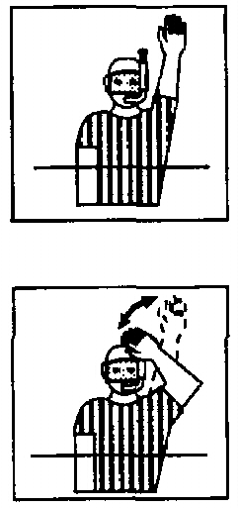Identify the following signals.

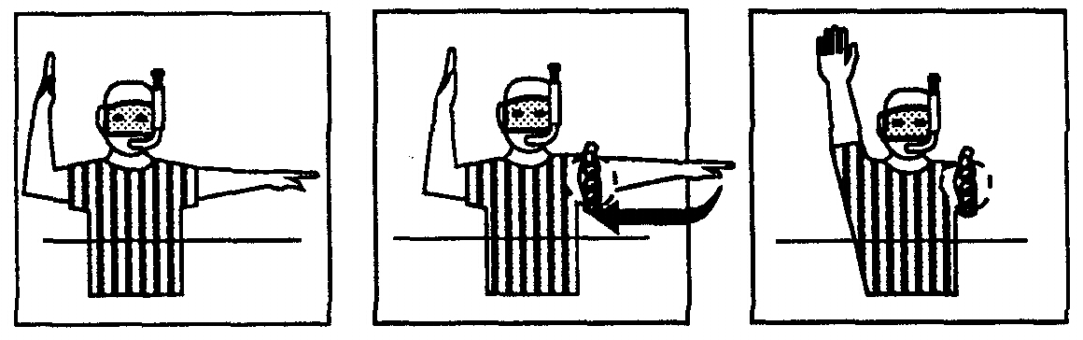
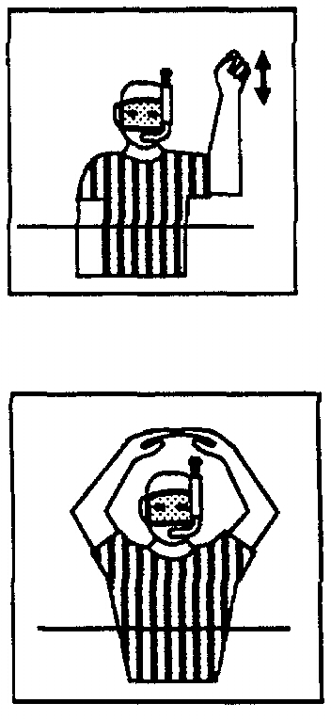
QUESTI0N 32: (4 MARKS)

In each of the following "X" marks where the puck has been played out of bounds. On the diagrams, mark with the letters "R" and "P" the correct position of Water Referees (3 water refs) and the puck. Specify distances in metres where appropriate.

a) The puck is played over the sideline by a black stick
b) The puck is played over the sideline by a white stick

X
White White

X

Black Black

- The puck is played over the goal line by a black stick
X
d) The puck is played over the goal line by a white stick

White White

Black Black

X
QUESTI0N 33: (4 MARKS)

In each of the following "X" marks where an infringement has occurred. On the diagram, mark with the letters "R" and "P" the correct position of Water Referees (3 water refs) and the puck for restarting play after the infringement has been awarded. Specify distances in metres where appropriate.

a) White infringes against black – no advantage to black.
b) White infringes against black inside the 3 metre ‘D’ – gloving on the tray.

White X White

X

Black Black

- Black break from a free puck taken by white at the X (5m out and 2m in)

d) The black centre forward fouls a white defender on the way to the white tray (just inside 3m ‘D’).

White X White

X

Black Black

